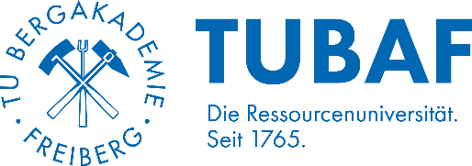
Faculty of Material Sciences and
Material Technologies
Institute for Nonferrous Metallurgy and Purest Materials

MASTER THESIS
Simulation-based LCA of Ti, FeTi, CuTi metal/alloy production
Introduction
Titanium (Ti) is a critical raw material essential for key European industrial ecosystems and several technological developments such as aerospace, electronics and energy technologies. However, Ti primary production is still limited to a few countries. Understanding the production pathways for titanium and its common alloys (FeTi & CuTi) and calculating their environmental impacts through simulation-based Life Cycle Assessment (LCA) is essential for a reliable assessment. This master's thesis aims to review the primary production of titanium and its common alloys, validate the flow sheets with industrial partners, and simulate these processes. Using simulation-based LCA, the impacts are assessed, and the key drivers of environmental hotspots are identified.

Tasks
- Literature review and process flow sheet definition
- Definition of Goal and Scope of LCA
- Data collection and life cycle inventory analysis
- Creation of HSC simulation models, supported with FactSage and OLI software information
- Calculation of impacts using HSC Sim and openLCA software
- Analysis, interpretation, and reporting of the analysed data
Requirements
- Basic knowledge of metallurgy/material science/chemistry or related fields
- Experience and/or interest in working with LCA (e.g., openLCA) and Simulation (e.g., HSC Sim)
- Start Date: Flexible
Benefits
- Opportunity to develop the topic in partnership with Minviro (UK-based LCA consultancy and software company)
- Opportunity to gain experience in Simulation-based LCA
- Possible publication of the relevant results
Contact
If you have any further questions or are interested to apply, please contact:
Prof. Dr.-Ing. Alexandros Charitos (Email: alexandros.charitos@inemet.tu-freiberg.de)
M.Sc. Thaís Veiga Barreiros (Email: Thais.Veiga-Barreiros@inemet.tu-freiberg.de )
M.Sc. Sahin Alacacayir (Email: sahin@minviro.com)

_____________________
Prof. Dr.-Ing. Alexandros Charitos, Institute Director, INEMET

