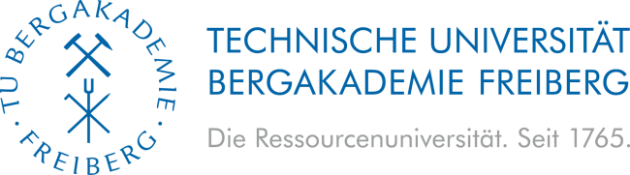
Faculty of Material Sciences and
Material Technologies
Institute for Nonferrous Metallurgy and Purest Materials

MASTER THESIS
Application of Safe and Sustainable by Design Framework for the assessment of Solid Oxide Electrolyser Cell recycling
Introduction
Nowadays, a sustainable future can not be achieved without the use of renewable energy carriers such as hydrogen, which can be efficiently produced by water electrolysis using energy from renewable sources. The master's thesis contributes to the government-funded project dealing with the industrial-scale production of solid oxide electrolyzers (SOEC) for the steel industry. In this complex topic, recycling should also be considered, as this is an indispensable part of a sustainable "zero-waste" future. The recycling process, developed by INEMET, is already being assessed considering technical and environmental perspective. As a next step, the process needs to be evaluated from economic and social perspectives, in addition to considering its hazardousness and the relevant waste regulations and directives. Therefore, the objective of this master’s thesis is the application of Safe and Sustainable by Design (SSbD) framework principle to evaluate the SOEC recycling.

Tasks
- General understanding and review of the SOEC recycling process.
- Literature review on economic and social assessment, relevant regulations, and SSbD application in the context of recycling process development.
- Applying the SSbD framework for evaluation of the in-house developed recycling process.
- Analysis, interpretation, and reporting of the analyzed data.
Requirements
- Basic knowledge in Metallurgy/Material Science/Chemistry or related.
- Experience and/or interest to work with Technical Economic Assessment and/or Life Cycle Costing, Social Assessment (e.g., social Life Cycle Assessment), SSbD, and general process evaluation through multi-criteria assessment techniques.
- Start Date: Flexible, but ideally as early as possible.
Benefits
- Extend your knowledge in the state-of-the-art field of study.
- Contribute to the circularity of materials for resource security.
- Publication of the relevant results.
Contact
If you have any further questions or interested to apply, please contact:
Prof. Dr.-Ing. Alexandros Charitos (Email: alexandros.charitos@inemet.tu-freiberg.de) and
M.Sc. Thaís Veiga Barreiros (Email: Thais.Veiga-Barreiros@inemet.tu-freiberg.de )

__________________________________
Prof. Dr.-Ing. Alexandros Charitos, Institute Director, INEMET

